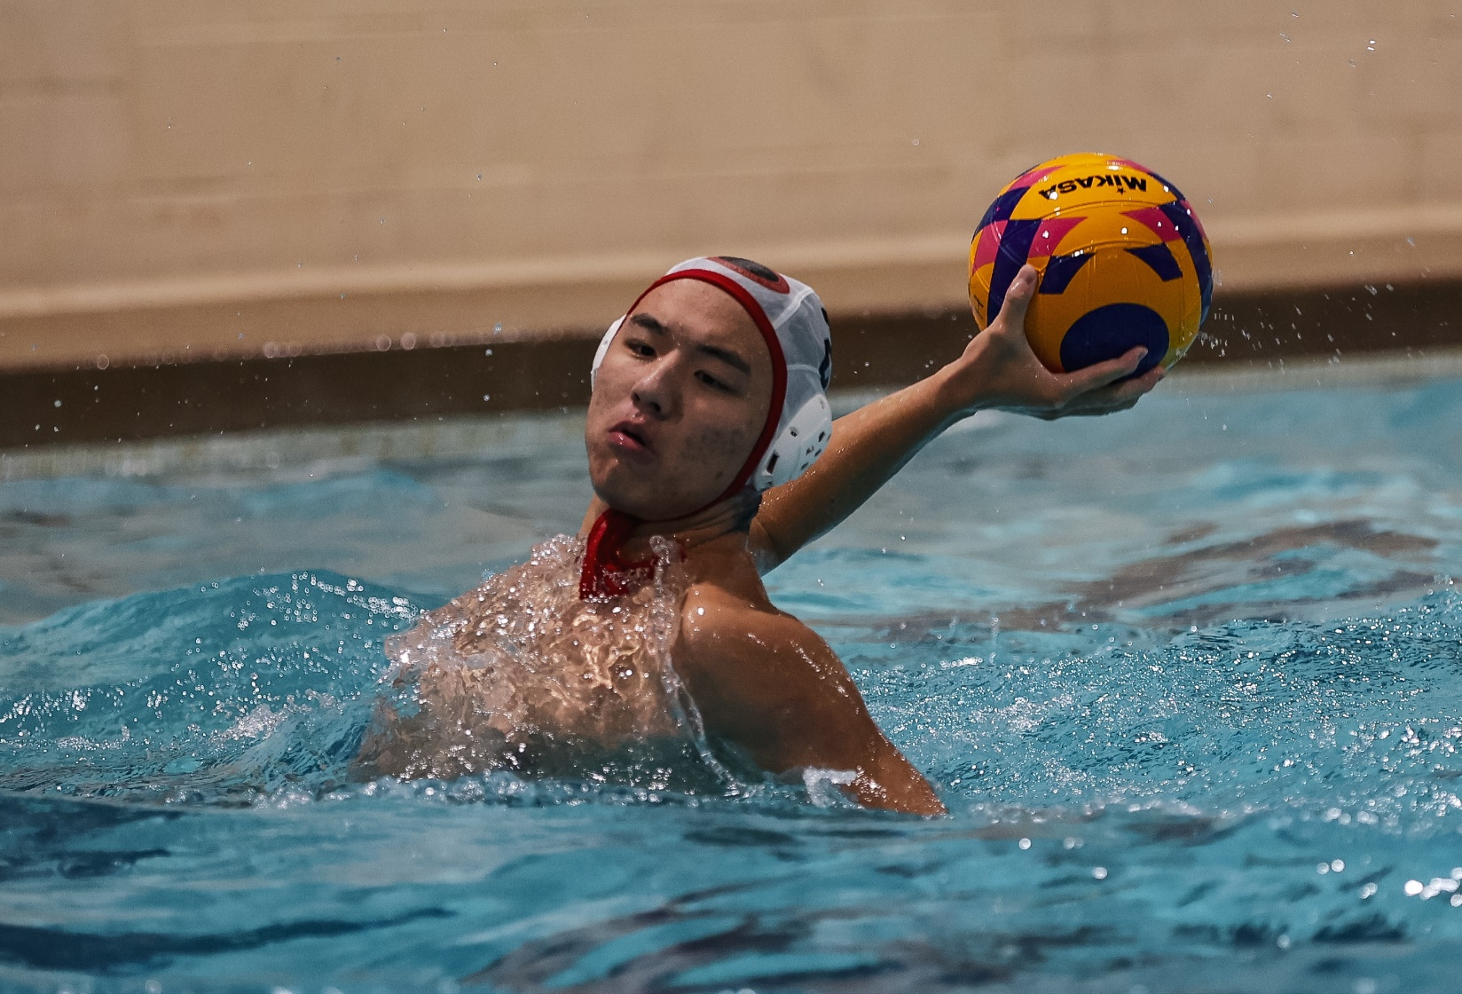

The YALE University Bulldogs men’s water polo team is proud to announce the addition of Andrew Yang to the 2026-27 roster.

Yang started playing water polo in 9th grade at The Lawrenceville School in New Jersey. In his sophomore year, he started playing club with CT Premier Water Polo. At Lawrenceville, he was named the Varsity Water Polo Captain and led the team to state championships for four consecutive years along with winning the 2024 Beast of the East tournament.

“Andrew brings a high level of play in all aspects of the game,” stated YALE men’s water polo Director of Recruiting George Gross, Jr. “He has a powerful, quick release shot from distance that is highly accurate. Proper defensive positioning is also a hallmark of his play.”

Outside the pool, Yang founded and led the Lawrenceville Learn to Swim program, a community initiative teaching 135+ students essential swimming and water safety skills. Through this program, he raised $15,500+ in external funding, oversaw the certification of almost 30 Red Cross WSI Instructors, and established a partnership with the Homefront organization to expand program access to 50+ underserved youth in the Trenton homeless community. He also led a research project, directing an original 500-person survey to investigate the relationship between socioeconomic factors and swimming proficiency among young adults.

“I chose YALE because I wanted to join a community that is passionate about learning and leadership,” enthused Yang. “I can't wait to take risks, pursue new interests, and lead new ventures. At YALE, I hope to continue pursuing multiple paths, leveraging the culture of curiosity to explore ideas both in the classroom and through real-world experiences.”

